# Laboratory 8

Title of the Laboratory Exercise: Introduction to Arduino UNO

1. Introduction and Purpose of Experiment

Students will be able to perform basic programming on Arduino UNO board

1. Aim and Objectives

Aim

To understand Arduino programming language and to develop basic programs using Arduino programming language.

Objectives

At the end of this lab, the student will be able to

* + Explain analog and digital pins in Arduino
  + Basic hardware programming language
  + Interface sensors and read values from sensors
  + Drive actuators

1. Experimental Procedure

1. Write algorithm to solve the given problem

2. Translate the algorithm to Arduino programming language

3. Execute it in Arduino IDE

4. Create a laboratory report documenting the work

1. Questions

Perform the following:

1. Print hello world in Arduino
2. Set High and LOW value to digital pin and print its output in serial monitor
3. Read Analog values and print it in serial monitor
4. Calculations/Computations/Algorithms

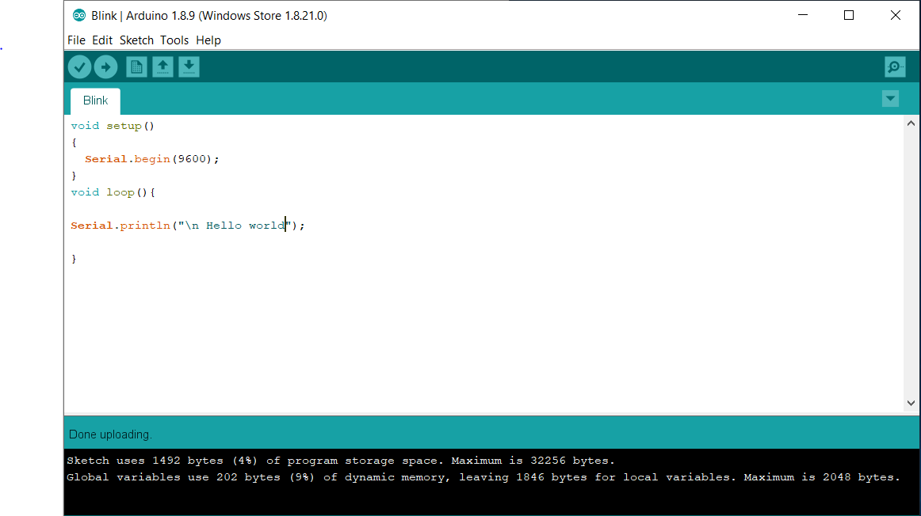

Fig 1. 1 Print hello world code.

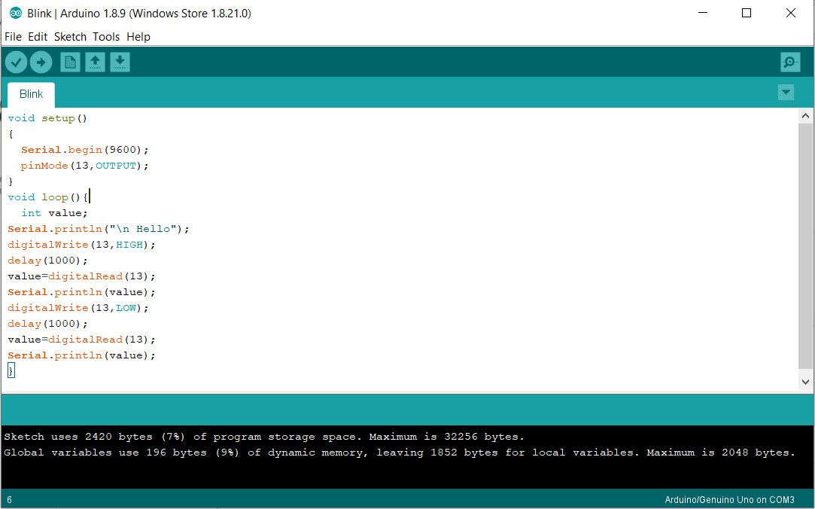

Fig 1. 2 High low code

1. Presentation of Results

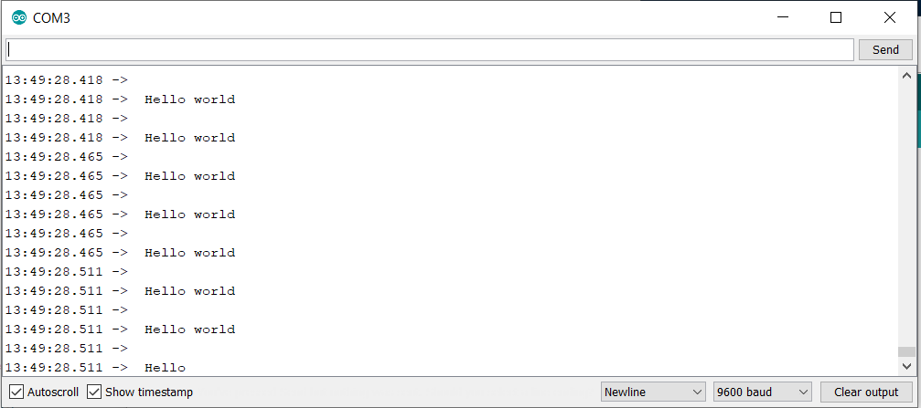

Fig 1. 3 serial monitor for code 1

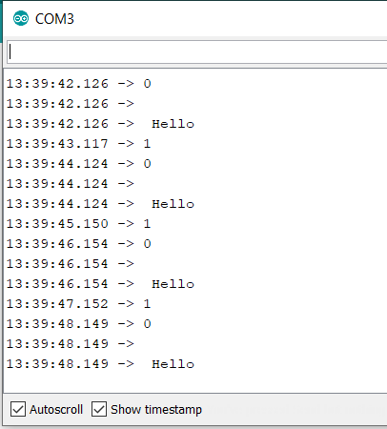

Fig 1. 4 serial monitor for code 2

1. Analysis and Discussions

In the sketch shown above, we can see some lines in grey colour in the top of the sketch and

some colourful lines in the bottom of the sketch.

1. Conclusions

Generally, comments are ignored by compilers. Hence, do not take up any space while

compiling. Comments are again divided in to block comments and line comments.

1. Comments

1. Limitations of Experiments

To power the Arduino, you either plug it in to a USB port, or you input a voltage source

to it either its 2.1 mm x 5.5 mm DC power jack via jumpers going to its “VIN” and “GND”

pins.

2. Learning happened

In this lab we have learnt how to explain analog and digital pins in Arduino, hardware

programming, interfacing sensors and read values from sensors.

Signature and date Marks